AI Systems Work2

Name: CAO Xinyang

HDU ID: 20321308

1. Screenshots with the goal resolutions.

All Facts:

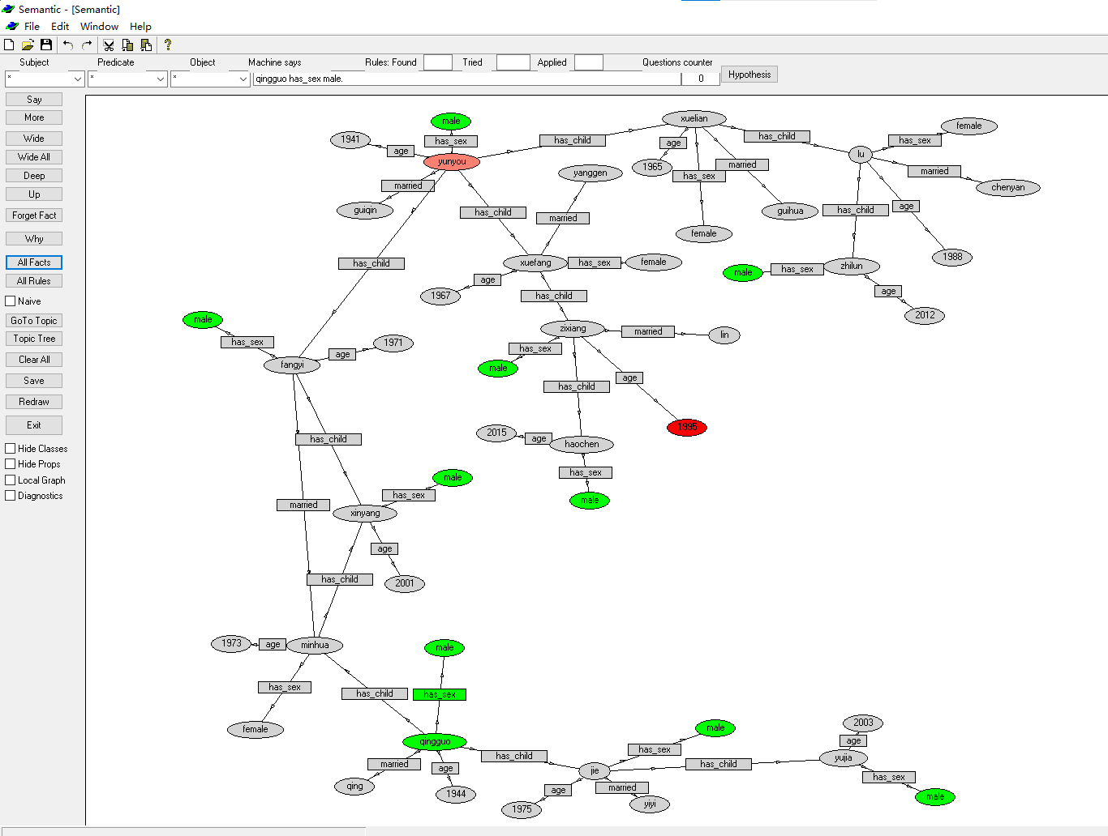

All Rules:

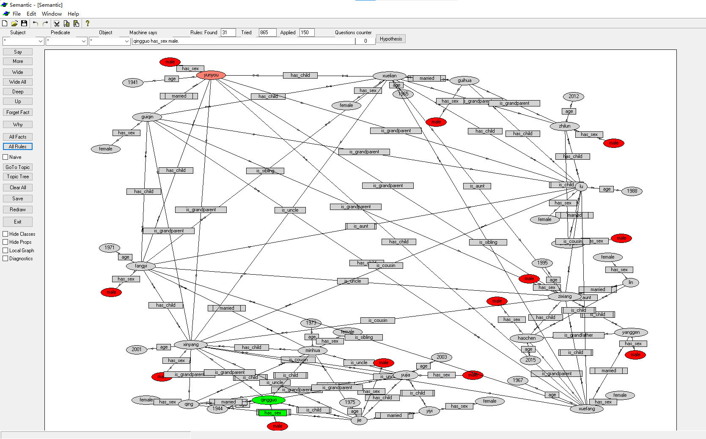

Screenshot on the working time:

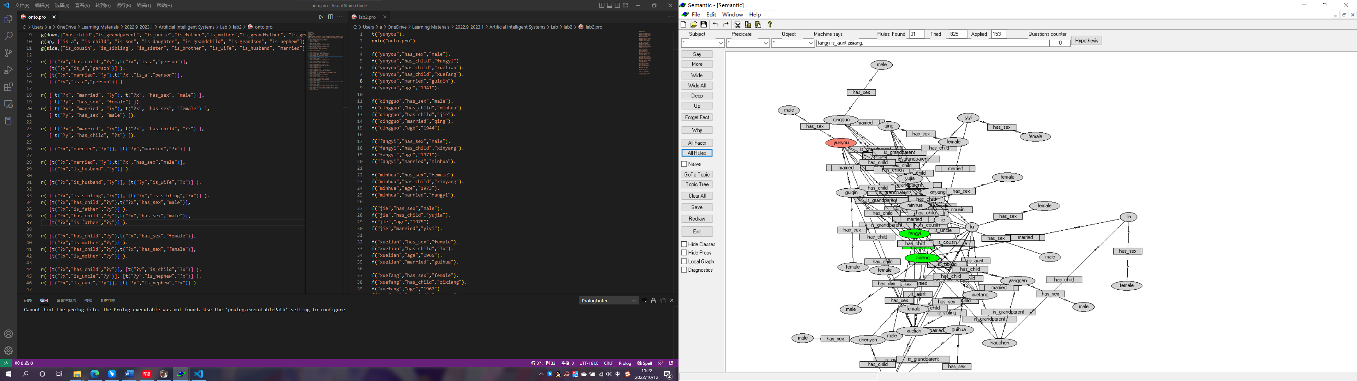

2. Codes

lab2.pro：

t("yunyou").

onto("onto.pro").

f("yunyou","has_sex","male").

f("yunyou","has_child","fangyi").

f("yunyou","has_child","xuelian").

f("yunyou","has_child","xuefang").

f("yunyou","married","guiqin").

f("yunyou","age","1941").

f("qingguo","has_sex","male").

f("qingguo","has_child","minhua").

f("qingguo","has_child","jie").

f("qingguo","married","qing").

f("qingguo","age","1944").

f("fangyi","has_sex","male").

f("fangyi","has_child","xinyang").

f("fangyi","age","1971").

f("fangyi","married","minhua").

f("minhua","has_sex","female").

f("minhua","has_child","xinyang").

f("minhua","age","1973").

f("minhua","married","fangyi").

f("jie","has_sex","male").

f("jie","has_child","yujia").

f("jie","age","1975").

f("jie","married","yiyi").

f("xuelian","has_sex","female").

f("xuelian","has_child","lu").

f("xuelian","age","1965").

f("xuelian","married","guihua").

f("xuefang","has_sex","female").

f("xuefang","has_child","zixiang").

f("xuefang","age","1967").

f("xuefang","married","yanggen").

f("zixiang","has_sex","male").

f("zixiang","has_child","haochen").

f("zixiang","age","1995").

f("zixiang","married","lin").

f("lu","has_sex","female").

f("lu","has_child","zhilun").

f("lu","age","1988").

f("lu","married","chenyan").

f("xinyang","has_sex","male").

f("xinyang","age","2001").

f("yujia","has_sex","male").

f("yujia","age","2003").

f("zhilun","has_sex","male").

f("zhilun","age","2012").

f("haochen","has_sex","male").

f("haochen","age","2015").

onto.pro：

c("person").

pr(["name"]).

pr(["age", "old"]).

pr(["has_sex"]).

pr(["male"]).

pr(["female"]).

g(down,["has_child","is_grandparent", "is_uncle","is_father","is_mother","is_grandfather", "is_grandmother"]).

g(up, ["is_a", "is_child", "is_son", "is_daughter", "is_grandchild", "is_grandson", "is_nephew"]).

g(side,["is_cousin", "is_sibling", "is_sister", "is_brother", "is_wife", "is_husband", "married"]).

r( [t("?x","has_child","?y"),t("?x","is_a","person")],

[t("?y","is_a","person")] ).

r( [t("?x","married","?y"),t("?x","is_a","person")],

[t("?y","is_a","person")] ).

r( [ t("?x", "married", "?y"), t("?x", "has_sex", "male") ],

[ t("?y", "has_sex", "female") ]).

r( [ t("?x", "married", "?y"), t("?x", "has_sex", "female") ],

[ t("?y", "has_sex", "male") ]).

r( [ t("?x", "married", "?y"), t("?x", "has_child", "?z") ],

[ t("?y", "has_child", "?z") ]).

r( [t("?x","married","?y")], [t("?y","married","?x")] ).

r( [t("?x","married","?y"),t("?x","has_sex","male")],

[t("?x","is_husband","?y")] ).

r( [t("?x","is_husband","?y")], [t("?y","is_wife","?x")] ).

r( [t("?x","is_sibling","?y")], [t("?y","is_sibling","?x")] ).

r( [t("?x","has_child","?y"),t("?x","has_sex","male")],

[t("?x","is_father","?y")] ).

r( [t("?x","has_child","?y"),t("?x","has_sex","male")],

[t("?x","is_father","?y")] ).

r( [t("?x","has_child","?y"),t("?x","has_sex","female")],

[t("?x","is_mother","?y")] ).

r( [t("?x","has_child","?y"),t("?x","has_sex","female")],

[t("?x","is_mother","?y")] ).

r( [t("?x","has_child","?y")], [t("?y","is_child","?x")] ).

r( [t("?x","is_uncle","?y")], [t("?y","is_nephew","?x")] ).

r( [t("?x","is_aunt","?y")], [t("?y","is_nephew","?x")] ).

r( [t("?x","has_child","?y"),t("?y","has_child","?z")],

[t("?x","is_grandparent","?z")] ).

r( [t("?x","is_grandparent","?y"),t("?x","has_sex","male")],

[t("?x","is_grandfather","?y")] ).

r( [t("?x","is_grandparent","?y"),t("?x","has_sex","male")],

[t("?x","is_grandfather","?y")] ).

r( [t("?x","is_grandparent","?y"),t("?x","has_sex","female")],

[t("?x","is_grandmother","?y")] ).

r( [t("?x","is_grandparent","?y"),t("?x","has_sex","female")],

[t("?x","is_grandmother","?y")] ).

r( [t("?x","has_child","?y"),t("?x","has_child","?z"),t("?y","differs","?z")],

[t("?y","is_sibling","?z")] ).

r( [t("?x","is_sibling","?y"),t("?x","has_sex","male")],

[t("?x","is_brother","?y")] ).

r( [t("?x","is_sibling","?y"),t("?x","has_sex","male")],

[t("?x","is_brother","?y")] ).

r( [t("?x","is_sibling","?y"),t("?x","has_sex","female")],

[t("?x","is_sister","?y")] ).

r( [t("?x","is_sibling","?y"),t("?x","has_sex","female")],

[t("?x","is_sister","?y")] ).

r( [t("?x","has_child","?y"),t("?x","is_sibling","?z"),t("?z","has_child","?a"),t("?y", "differs","?a")],

[t("?y","is_cousin","?a")] ).

r( [t("?x","has_child","?y"),t("?x","is_sibling","?z"), t("?z","has_sex", "male")],

[t("?z","is_uncle", "?y")] ).

r( [t("?x","has_child","?y"),t("?x","is_sibling","?z"), t("?x","has_sex","male")],

[t("?z","is_uncle", "?y")] ).

r( [t("?x","has_child","?y"),t("?x","is_sibling","?z"), t("?z","has_sex", "female")],

[t("?z","is_aunt", "?y")] ).

r( [t("?x","has_child","?y"),t("?x","is_sibling","?z"), t("?x","has_sex","female")],

[t("?z","is_aunt", "?y")] ).

3. Summary

With software Semantic we can quickly build a diagram to clarify the relationship between each object. This is a very useful software. We should master this skill expertly.

That’s all for lab work2, thank you for checking.